Adjacent Supplementary Angles (Linear Pair)

Definition
# Source: AI Source: Provided by: [Data Path: Persons Table -> ID Column: 1, Name_En Column: Motasem Essam] -> From: [ChatGPT] on [7/25/2026]
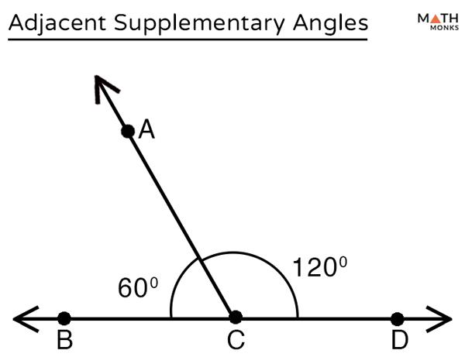
Adjacent Supplementary Angles are two adjacent angles whose measures add up to exactly ${180}^{∘}$.
When the two adjacent angles have non-common sides that are opposite rays, they form a linear pair.
Therefore, a linear pair satisfies both conditions:
$$\boxed{\text{Adjacent}+\text{Supplementary}}$$
and its non-common sides form a straight line.

Simple Definition
# Source: AI Source: Provided by: [Data Path: Persons Table -> ID Column: 1, Name_En Column: Motasem Essam] -> From: [ChatGPT] on [7/25/2026]
Adjacent Supplementary Angles (Linear Pair) are two adjacent angles whose measures add up to ${180}^{∘}$, with their non-common sides forming a straight line.

Conditions
# Source: AI Source: Provided by: [Data Path: Persons Table -> ID Column: 1, Name_En Column: Motasem Essam] -> From: [ChatGPT] on [7/25/2026]
Two angles form a linear pair when all of the following are true:
1. They Have a Common Vertex
For example:
$$∠ABC$$
and
$$∠CBD$$
both have vertex $B$.
2. They Have One Common Side
The angles share:
$$\vec{BC}$$
3. Their Interiors Do Not Overlap
The two angles are next to each other rather than overlapping.
4. Their Non-Common Sides Are Opposite Rays
For example:
$$\vec{BA}$$
and
$$\vec{BD}$$
are opposite rays.
Thus, they form a straight line:
$$A⟶B⟶D$$
5. Their Measures Add to ${180}^{∘}$
$$\boxed{m∠ABC+m∠CBD={180}^{∘}}$$

Example
Suppose:
$$m∠ABC={120}^{∘}$$
and
$$m∠CBD={60}^{∘}$$
Then:
$${120}^{∘}+{60}^{∘}={180}^{∘}$$
Since the angles are adjacent and their non-common sides form a straight line, they form a linear pair.

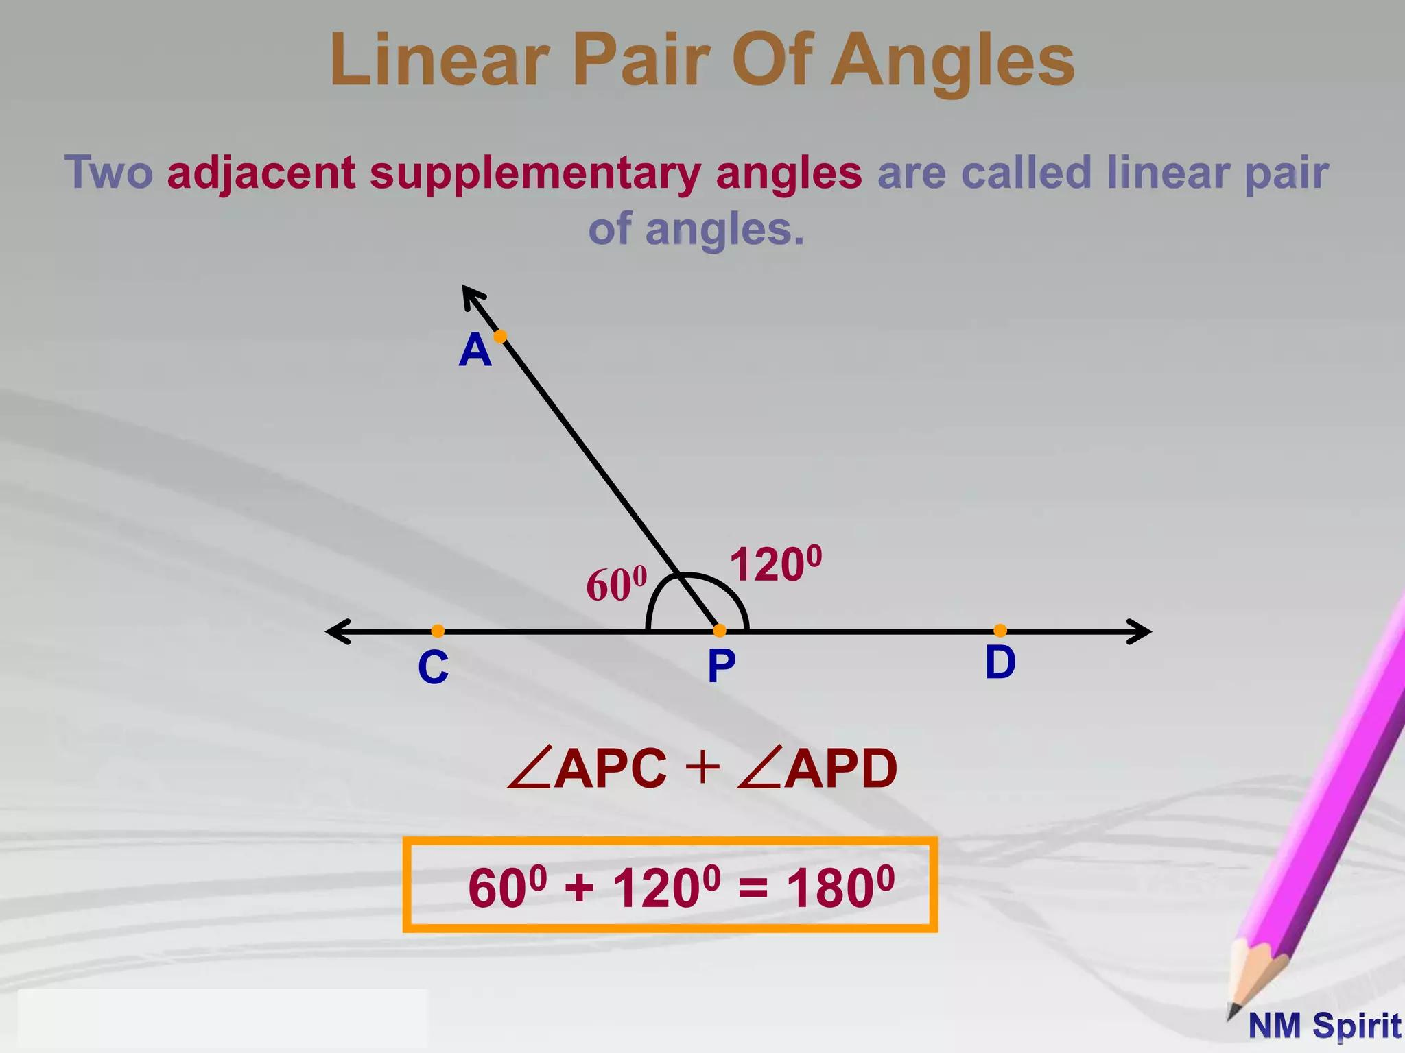
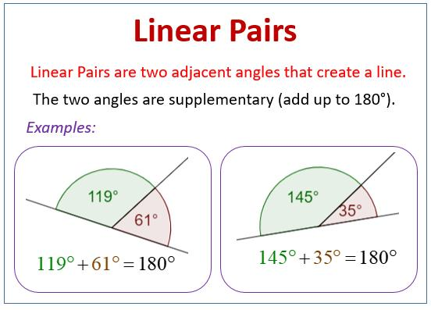
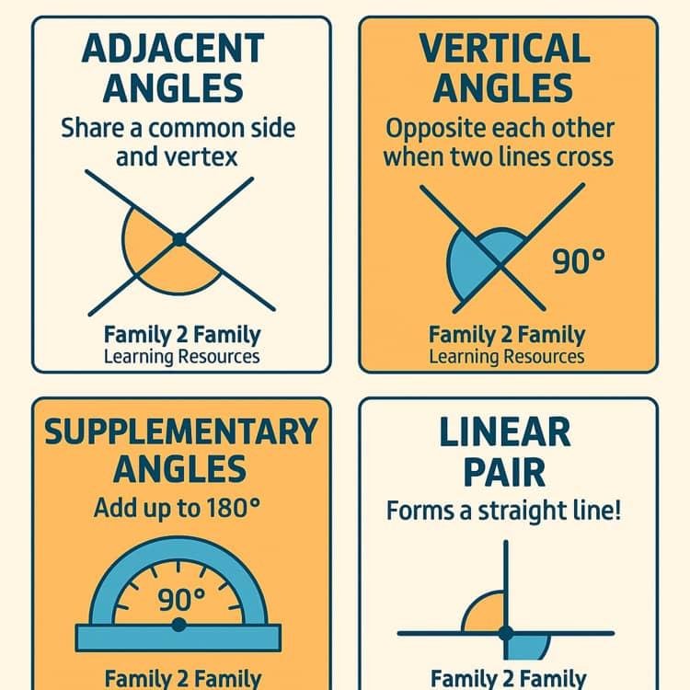
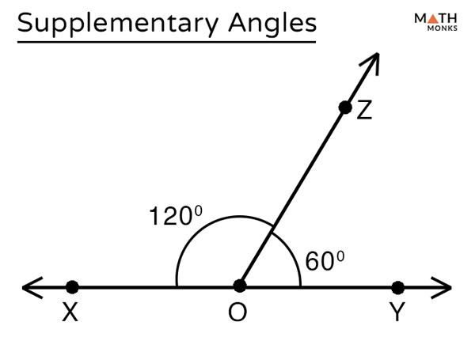
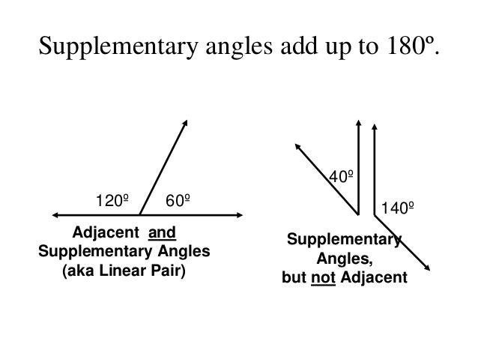
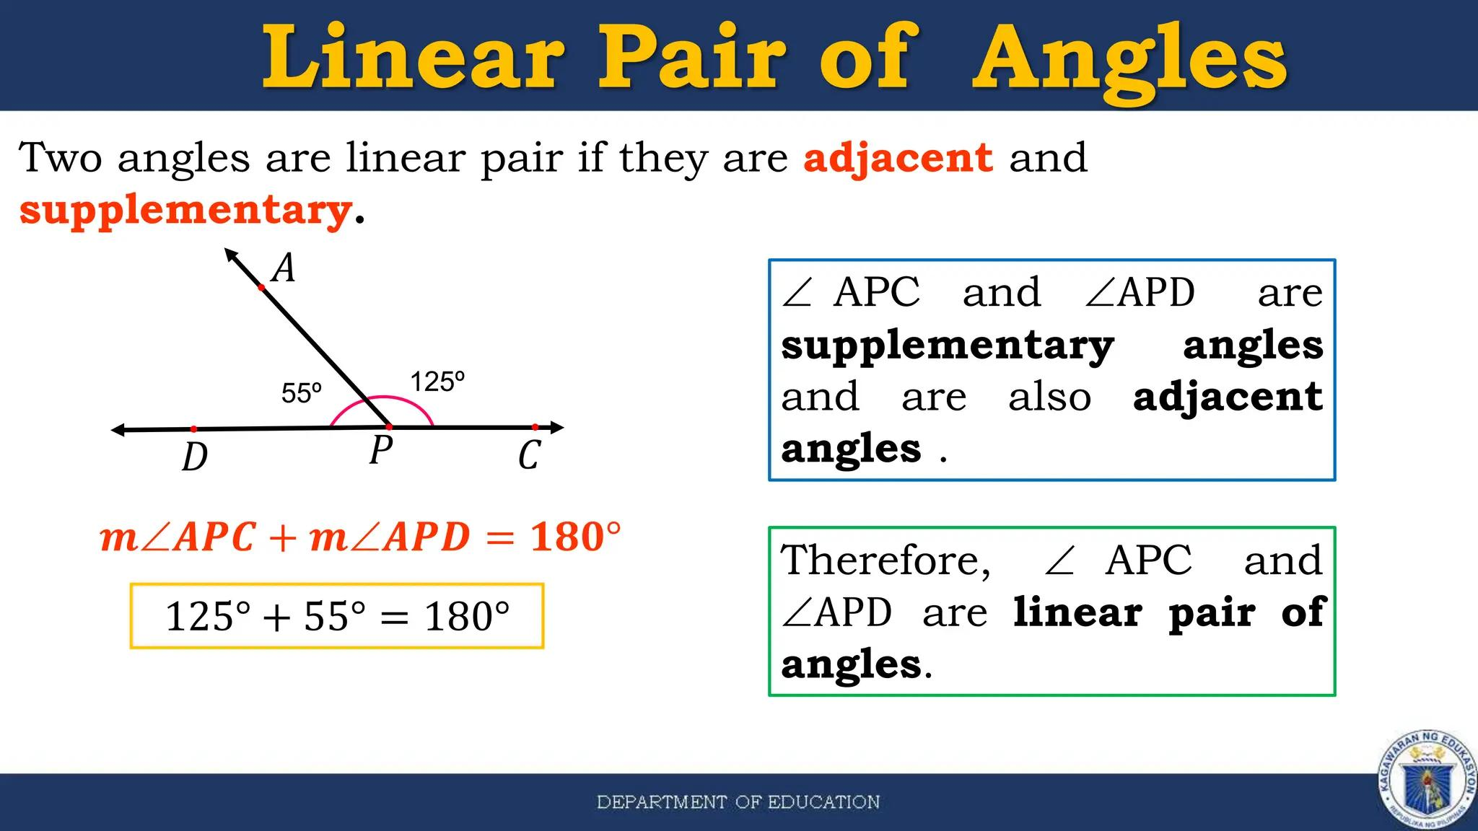
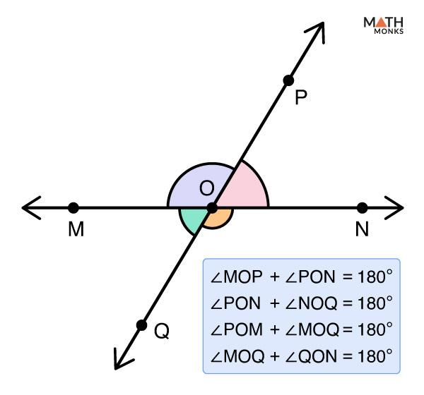

Different Examples
# Source: AI Source: Provided by: [Data Path: Persons Table -> ID Column: 1, Name_En Column: Motasem Essam] -> From: [ChatGPT] on [7/25/2026]
Example 1: ${100}^{∘}$and ${80}^{∘}$
$${100}^{∘}+{80}^{∘}={180}^{∘}$$
They can form a linear pair.
Example 2: ${135}^{∘}$and ${45}^{∘}$
$${135}^{∘}+{45}^{∘}={180}^{∘}$$
They can form a linear pair.
Example 3: ${90}^{∘}$and ${90}^{∘}$
$${90}^{∘}+{90}^{∘}={180}^{∘}$$
If they are adjacent and their non-common sides are opposite rays, they form a linear pair.
Example 4: ${150}^{∘}$and ${30}^{∘}$
$${150}^{∘}+{30}^{∘}={180}^{∘}$$
They can form a linear pair.

Linear Pair Theorem
# Source: AI Source: Provided by: [Data Path: Persons Table -> ID Column: 1, Name_En Column: Motasem Essam] -> From: [ChatGPT] on [7/25/2026]
The Linear Pair Theorem states:
If two angles form a linear pair, then they are supplementary.
Therefore:
$$\boxed{m∠1+m∠2={180}^{∘}}$$
Example
If:
$$m∠1={125}^{∘}$$
then:
$$m∠2={180}^{∘}-{125}^{∘} \\ \boxed{m∠2={55}^{∘}}$$

Converse
# Source: AI Source: Provided by: [Data Path: Persons Table -> ID Column: 1, Name_En Column: Motasem Essam] -> From: [ChatGPT] on [7/25/2026]
The converse requires an important distinction.
If two angles are adjacent and their measures add to ${180}^{∘}$, then their non-common sides form a straight angle. Therefore, they form a linear pair.
However, simply knowing that two arbitrary angles are supplementary is not enough to conclude that they form a linear pair.
For example, two separate angles measuring:
$${120}^{∘} \text{and} {60}^{∘}$$
are supplementary, but they are not necessarily a linear pair because they may not be adjacent.

Linear Pair vs Supplementary Angles
# Source: AI Source: Provided by: [Data Path: Persons Table -> ID Column: 1, Name_En Column: Motasem Essam] -> From: [ChatGPT] on [7/25/2026]
These terms are related but not identical.
Supplementary Angles
Two angles are supplementary if:
$$\boxed{A+B={180}^{∘}}$$
They do not have to be adjacent.
Linear Pair
Two angles form a linear pair if:
- They are adjacent.
- Their non-common sides are opposite rays.
Therefore:
$$\boxed{\text{Linear Pair}⇒\text{Supplementary}}$$
But:
$$\boxed{\text{Supplementary}⇏\text{Linear Pair}}$$
unless adjacency and the straight-line condition are also established.

Linear Pair vs Adjacent Complementary Angles
# Source: AI Source: Provided by: [Data Path: Persons Table -> ID Column: 1, Name_En Column: Motasem Essam] -> From: [ChatGPT] on [7/25/2026]
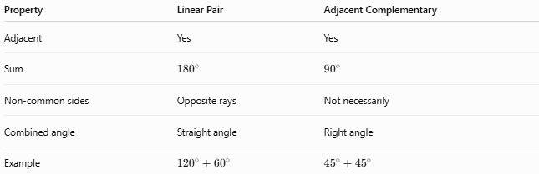
Property | Linear Pair | Adjacent Complementary
Adjacent | Yes | Yes
Sum | $${180}^{∘}$$ | $${90}^{∘}$$
Non-common sides | Opposite rays | Not necessarily
Combined angle | Straight angle | Right angle
Example | $${120}^{∘}+{60}^{∘}$$ | $${45}^{∘}+{45}^{∘}$$

Linear Pair and Right Angles
# Source: AI Source: Provided by: [Data Path: Persons Table -> ID Column: 1, Name_En Column: Motasem Essam] -> From: [ChatGPT] on [7/25/2026]
A linear pair can contain:
Two Right Angles
$${90}^{∘}+{90}^{∘}={180}^{∘}$$
One Acute and One Obtuse Angle
For example:
$${40}^{∘}+{140}^{∘}={180}^{∘}$$
So, in a linear pair:
- if one angle is acute, the other is obtuse;
- if one angle is right, the other must also be right;
- two obtuse angles cannot form a linear pair;
- two acute angles cannot form a linear pair.

Important Property
# Source: AI Source: Provided by: [Data Path: Persons Table -> ID Column: 1, Name_En Column: Motasem Essam] -> From: [ChatGPT] on [7/25/2026]
If one angle in a linear pair is $x^{∘}$, the other is:
$$\boxed{{180}^{∘}-x^{∘}}$$
For example:
$$x={70}^{∘}$$
so:
$${180}^{∘}-{70}^{∘}={110}^{∘}$$
Thus:
$$\boxed{{70}^{∘}+{110}^{∘}={180}^{∘}}$$

Visual Structure
# Source: AI Source: Provided by: [Data Path: Persons Table -> ID Column: 1, Name_En Column: Motasem Essam] -> From: [ChatGPT] on [7/25/2026]
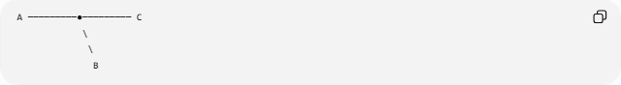
A ─────────●───────── C
\
\
B
At $O$, the two angles share one side, while their other sides point in opposite directions:
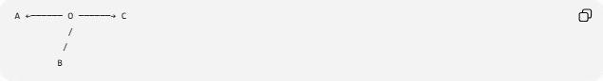
A ←────── O ──────→ C
/
/
B
The straight line gives:
$$m∠AOC={180}^{∘}$$
and the common ray divides this straight angle into two adjacent angles:
$$\boxed{m∠AOB+m∠BOC={180}^{∘}}$$

Key Formulas
# Source: AI Source: Provided by: [Data Path: Persons Table -> ID Column: 1, Name_En Column: Motasem Essam] -> From: [ChatGPT] on [7/25/2026]
$$\boxed{A+B={180}^{∘}}$$
For an unknown angle:
$$\boxed{B={180}^{∘}-A}$$
In radians:
$$\boxed{A+B=π}$$

Key Points
# Source: AI Source: Provided by: [Data Path: Persons Table -> ID Column: 1, Name_En Column: Motasem Essam] -> From: [ChatGPT] on [7/25/2026]
- A linear pair consists of two adjacent angles.
- Their measures add to ${180}^{∘}$.
- Their non-common sides are opposite rays.
- They form a straight angle.
- Every linear pair consists of supplementary angles.
- Not every pair of supplementary angles is a linear pair.
- A linear pair containing a right angle must contain another right angle.
- A linear pair containing an acute angle has an obtuse other angle.

Conclusion
# Source: AI Source: Provided by: [Data Path: Persons Table -> ID Column: 1, Name_En Column: Motasem Essam] -> From: [ChatGPT] on [7/25/2026]
Adjacent Supplementary Angles (Linear Pair) are adjacent angles that together form a straight angle. Their measures always satisfy:
$$\boxed{A+B={180}^{∘}}$$
The defining geometric feature of a linear pair is that the two non-common sides are opposite rays.

